**Some notes on the adoption of RAC**

**to systematically evaluate nuclear data**

Zhenpeng Chen

Physics Department, Tsinghua University, Beijing, China

Yeying Sun

Material Science Department, Tsinghua University, Beijing, China

（2023-03-14 ）

RAC uses the 'Generalized least squares method' (GLS) and the 'Reduced R-matrix model' to simultaneously analyze all available experimental data about a nuclear system, making it possible to obtain a broader and more reliable evaluation of experimental data, including neutron and charged particle incidence. The work that has been attempted so far involves an energy region from En=1.0E-7 MeV to 30 MeV, with A=1, 16 for the target nuclides. In 2018, we completed the systematic evaluation of 7Be primarily, and the specific results have been reported at relevant meetings organized by the IAEA and distributed to participants. See: **A GLOBAL FITTING METHOD WITH THE R-MATRIX CODE RAC, IAEA, INDC (NDS) -0791 (2019)**. In 2022, we tried to make some improvements and found that the change in rating value was too small to be meaningful for the application. **The RAC evaluation work is still under development and has not yet reached the level of official release**. Therefore, at this meeting, we will only briefly introduce the results of our work in 2018 and highlight some views for your advice. Refer to the papers ‘**A global fitting for 7Be system with GLS’ and ‘A new method for evaluation of nuclear data--RAC-CENGEPLIS’.**

**I. Briefly introduce the results of our work in 2018**

The Global data-base of 7Be system includes all available data from EXFOR, and some data got from this co-operation. The 6Li(p, p) 6Li and 4He(3He, 3He) 4He have the most complete and most accurate experimental data-sets, which play dominant function in fitting; the fitting of 6Li(p, 3He) 4He and 4He(3He,p) 6Li are depend on the 6Li(p, p) 6Li and 4He(3He, 3He) 4He, of cause 6Li(p, 3He) 4He and 4He(3He,p) 6Li have some extent competition. For 6Li(p,p1)6Li*, 6Li(p,p2)6Li**, 6Li(p, g)7Li, 4He(3He p1)6Li,4He(3He,g)7Li, each has a free parameter to search, so the most of shape factors in them are keep as 1.00. Some Analyzing power data were used too. Refer to **Appendix 2. Some information about the experimental data.**

Partial comparison plots and calculation results are shown below. Only one graph is displayed for each reaction channel.

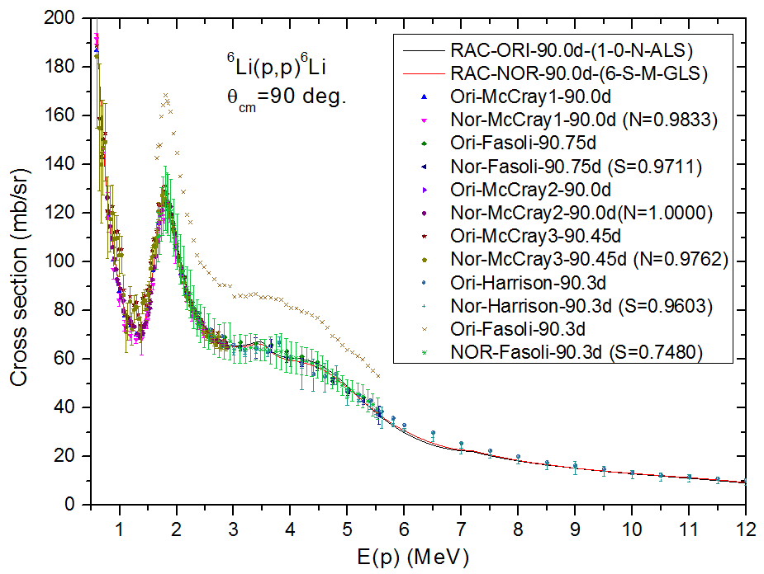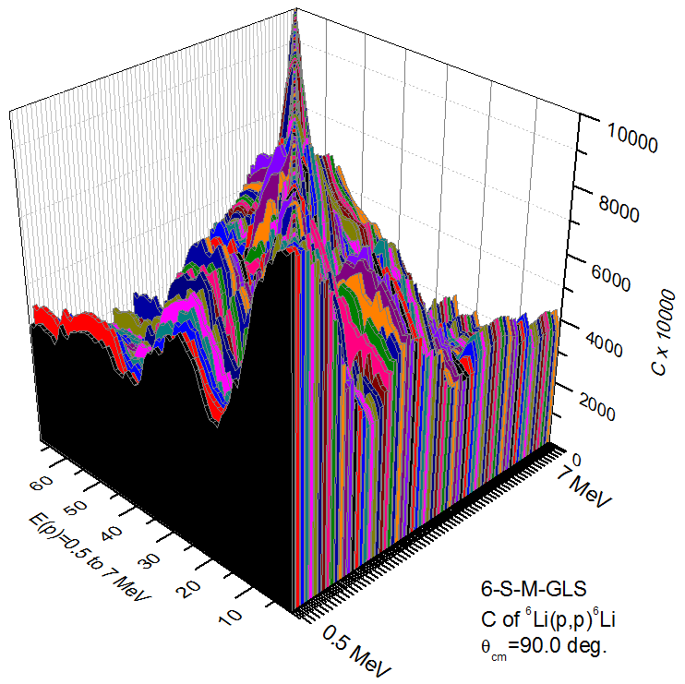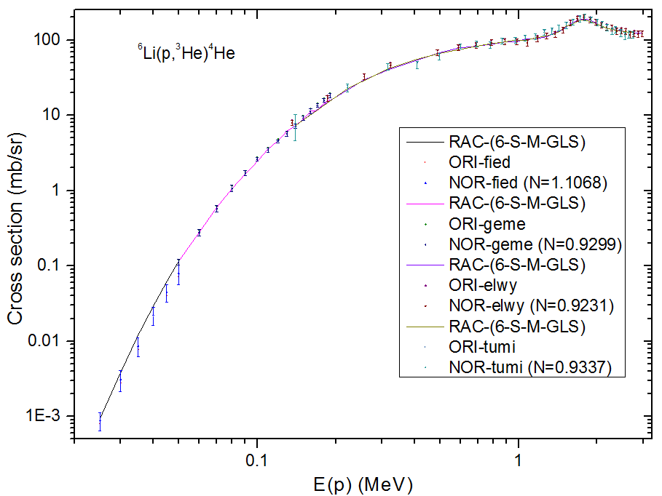

FIG 1. (left). The 6Li (p, p) 6Li excitation function at 90 degrees, the fits are excellent. (middle) The correlation factor (C) for the excitation function of 6Li(p,p) 6Li at 90 degrees, and Ep = 0.5 to 7 MeV. In the C matrix the diagonal elements Cii ≡ 1. (right) The integrated cross section of the 6Li(p, 3He)4He reaction, the fit is very good.

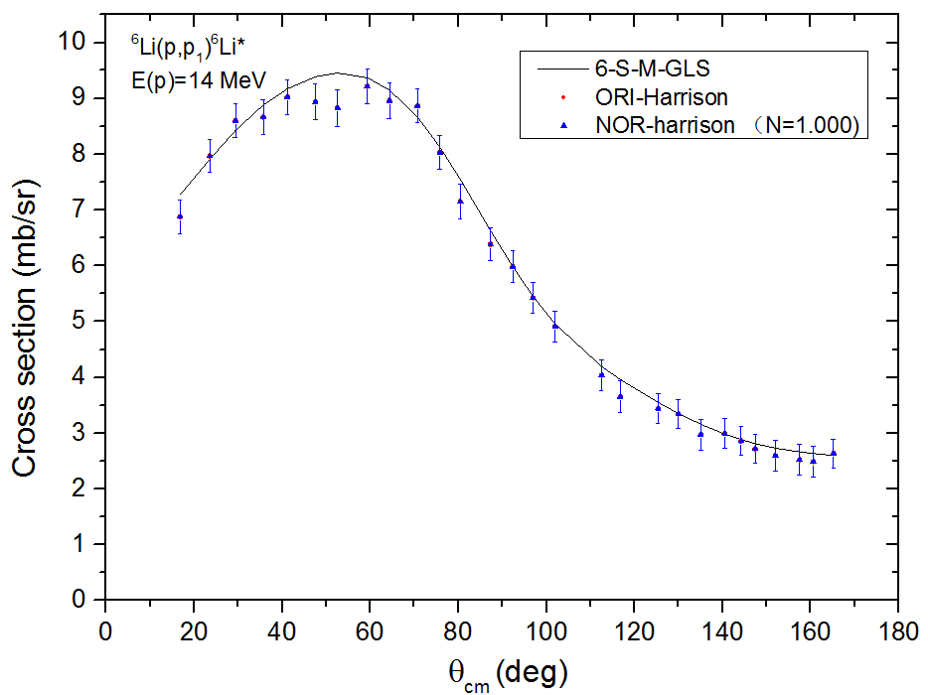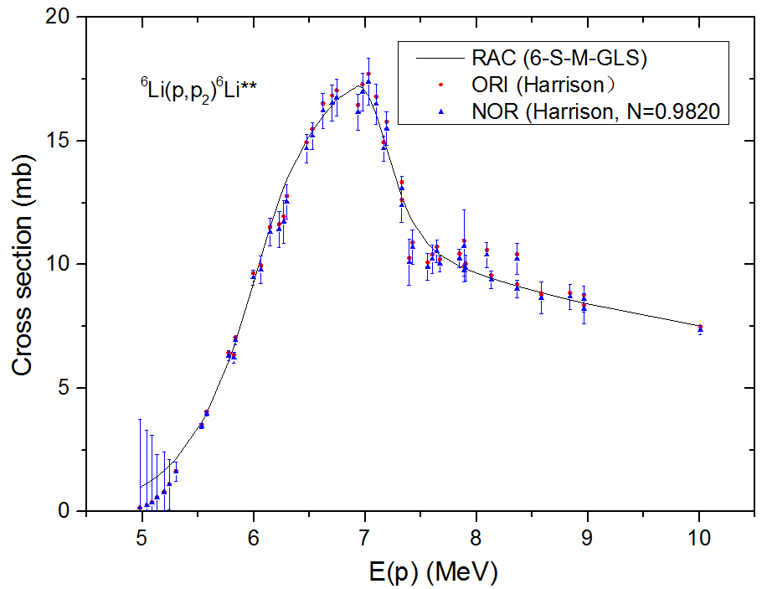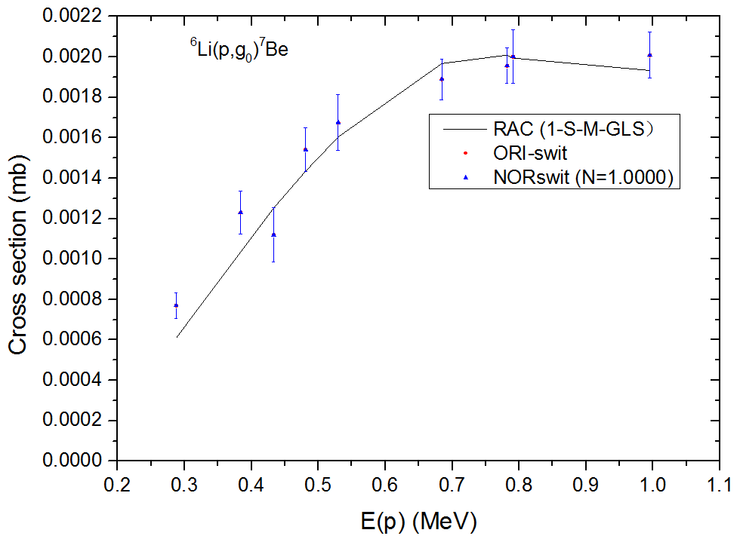

FIG 2. (left).The fit of the DA of 6Li (p,p1) 6Li* at Ep = 14 MeV, which is the largest energy used in database located in the non-resolved resonance region. (middle) The fit of the integrated cross sections of 6Li(p,p2)6Li** , N=1 means that the data are not normalized.. The fit looks good. (right) The fit for the integrated cross section of 6Li(p,γ0)7Be. N=1 means data are not normalized. The fit looks good.

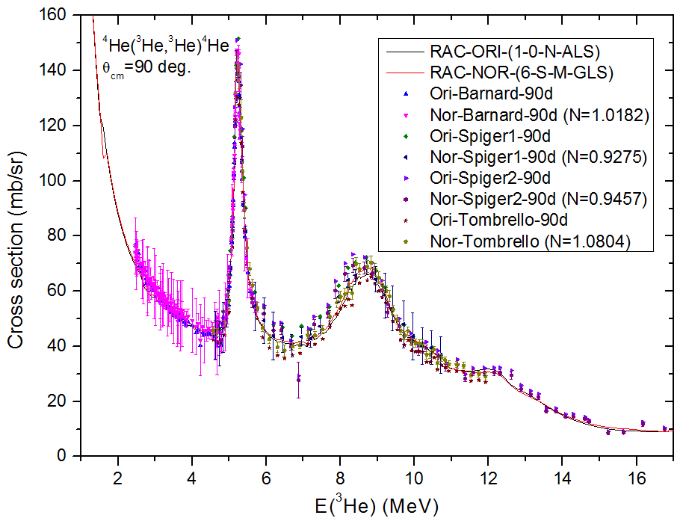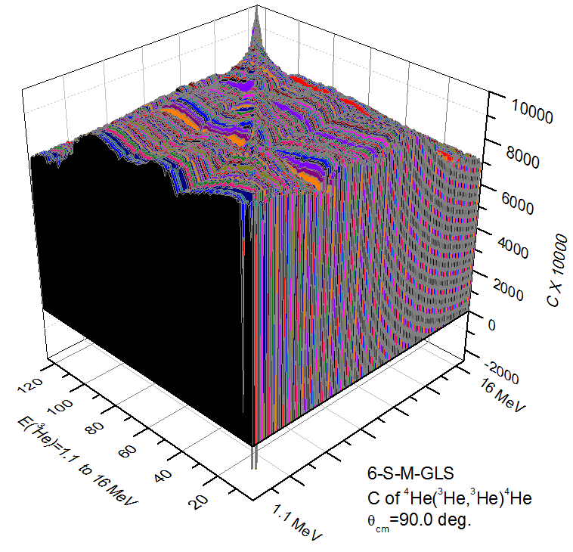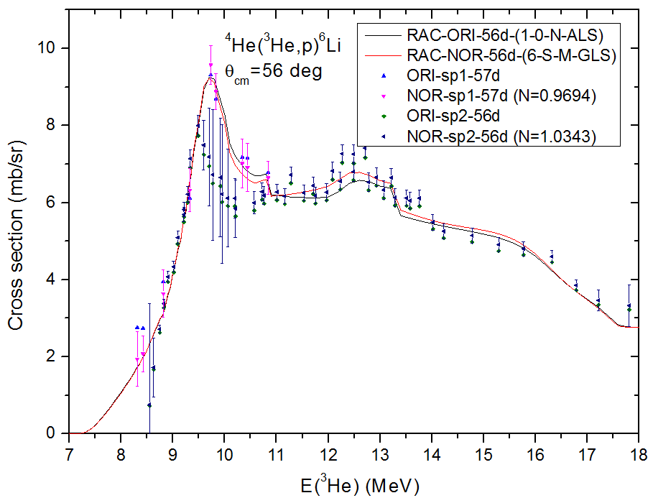

FIG 3. (left). Fit for the excitation function of 4He(3He,3He)4He at 90 degrees. The data from 14 to 18 MeV are in the non-resolved resonance region. (middle) Correlation factor (C) for the excitation function of 4He (3He,3He)4He at 90 degrees for E3He = 1.1 MeV to 16 MeV. (right) Fit for the excitation function of 4He(3He,p)6Li at 56 degrees. N = 0.9694, 1.0343 are the NCs.

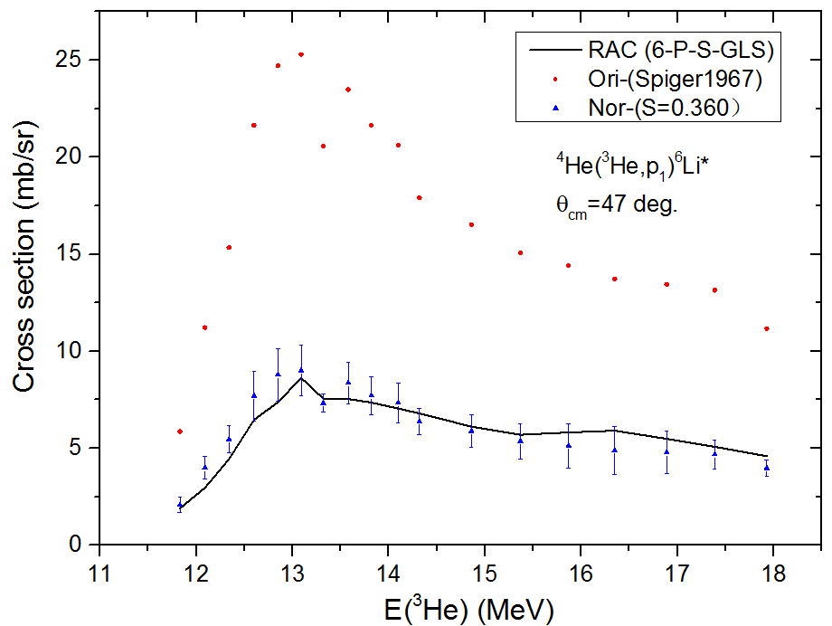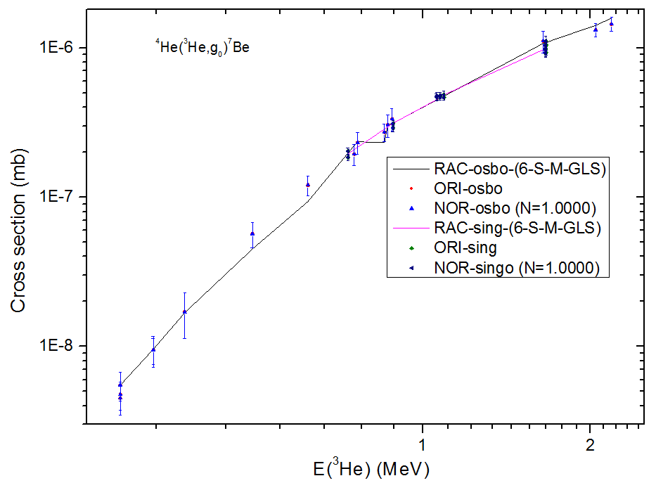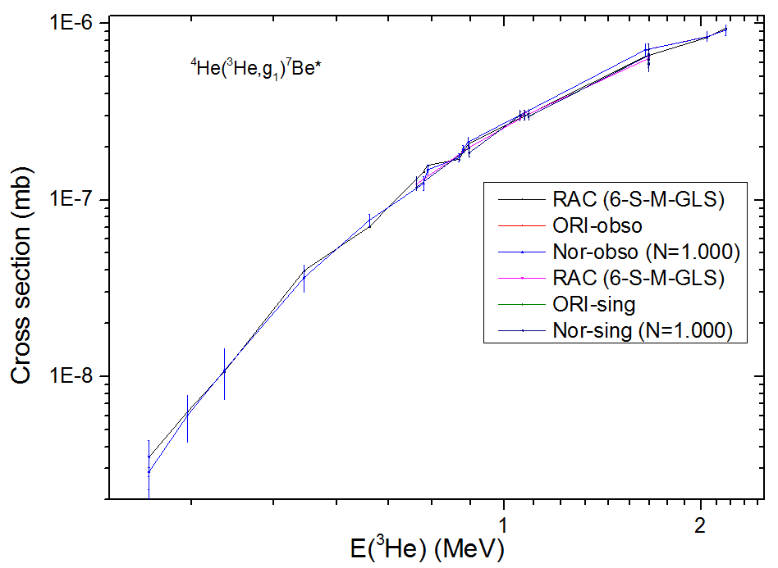

FIG 4. (left) Fit for the excitation function of 4He( 3He,p1)6Li* at 47degrees, these are shape data. (middle) Fit for integrated cross sections of 4He(3He,γ0)7Be. (right) Fit for integrated cross sections of 4He(3He,γ1)7Be*.

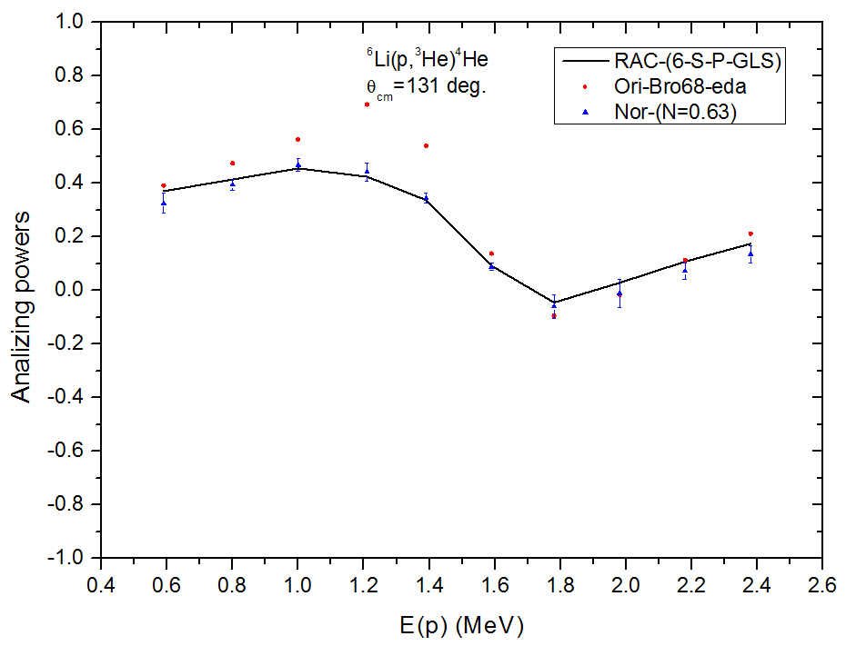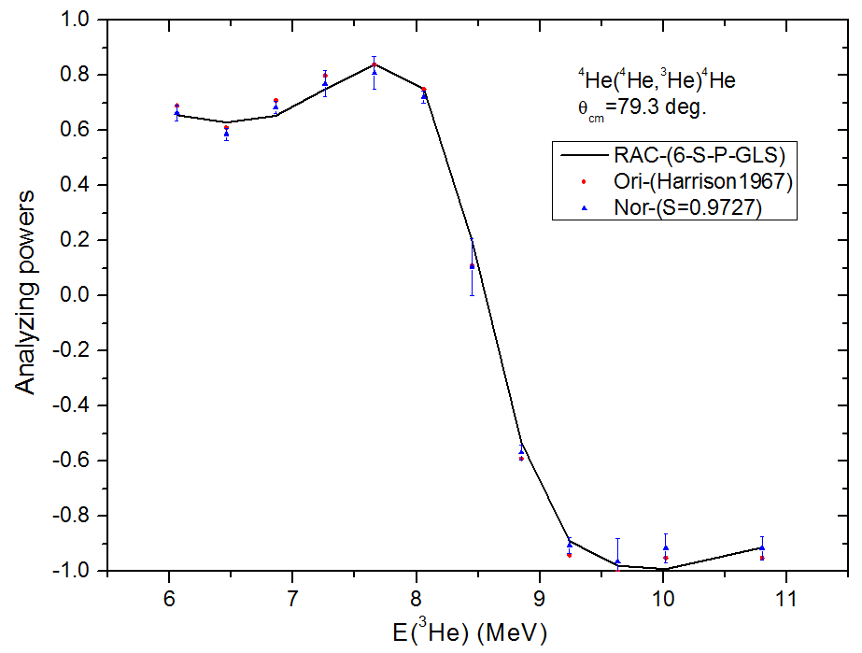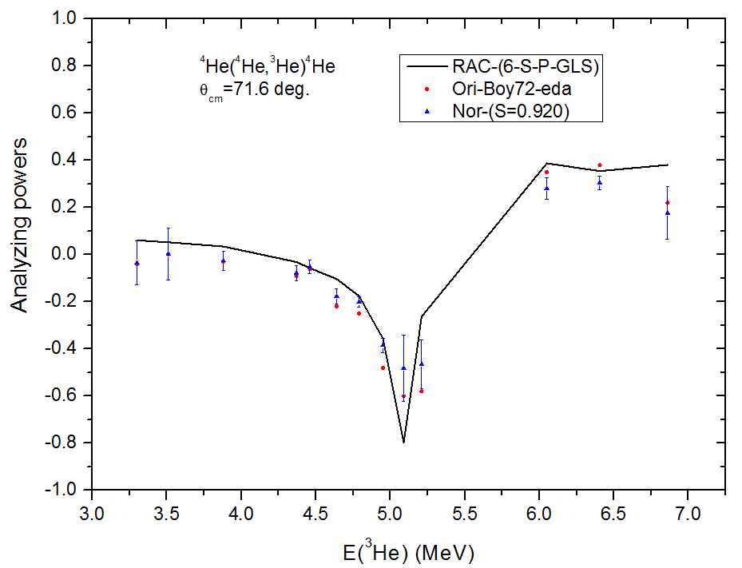

FIG 5. (left) Fit for Analyzing Power of 6Li (p, 3He) 4He at 131degree, these are shape data. (middle) Fit for Analyzing power of 4He(3He, 3He) 4He at 79.3degree, (right) Fit for Analyzing power of 4He(3He, 3He) 4He at 71.6 degree.

**II. Highlight some views for your advice**

Briefly, these views include:

A. Disadvantages of the approximate expression used in Nijmegen's group;

B. GLS has a high sensitivity to , which is conducive to obtaining the best normalization coefficient;

C. How to do system error correction, Angle correlation correction and Energy correlation correction;

D. The revised experimental data set, including principal values and errors, should be used in the iterative process;

E. The original error or corrected error of the data set can be used to calculate the covariance of the evaluation value finally;

F. The error calculated by the error transfer formula is significantly different from the error calculated by the Monte Carlo method;

G. The total reduced channel width parameter Γ can be flexibly applied to multiple classes;

H. RAC is based on experimental data to determine the adopted energy level parameters, while using statistical model is based on the given energy level parameters for calculation;

I. If the fitting procedures of different models are adopted, the calculation results are difficult to be repeated with each other. As long as four significant digits of the main calculated values are consistent, the requirements of phenomenological fitting can be met. As long as the evaluation results are close;

J. Do the ALS, CLS and GLS methods give the same results, or different?

K. How to evaluate the reliability of system-wide data fitting;

L. The documentation of the evaluation library can be in the format used by SAMMY for light uncles, that is, to publish the calculated values of various sections rather than parameters. Let's say 35Cl.

Detailed instructions are given below.

**A. Disadvantages of the approximate χ2 expression used in Nijmegen's group;**

The various least squares methods are discussed in detail in D. L. Smith's book: *Probability, Statistics, and Data Uncertainties in Nuclear Science and Technology* (Amer Nuclear Society, Chicago, 1991)。

Of the various expressions, 'Convectional least squares'（CLS）and 'Generalized least squares' （GLS））uses the covariance matrix of the experimental data, and we will call those that do not use the covariance matrix as 'Approximate least squares’（ALS），except for purely statistical samples. Appendix 1: Table 1 shows partially representative expressions. Among them, the ‘approximate least squares’ used by Nijmegen's research group is a representative one. Refer to J. R. Bergervoet, P. C. van Campen, PhysRevC.38.15(1988). Below is a copy of the original argument.

Copy：Expression of approximation for non-statistical samples (66)

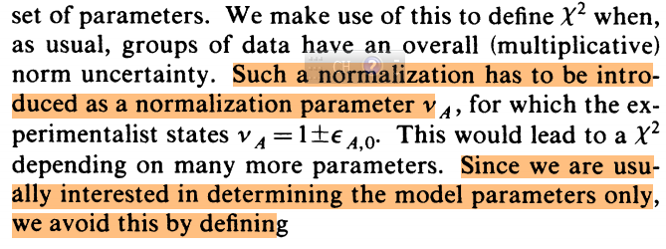

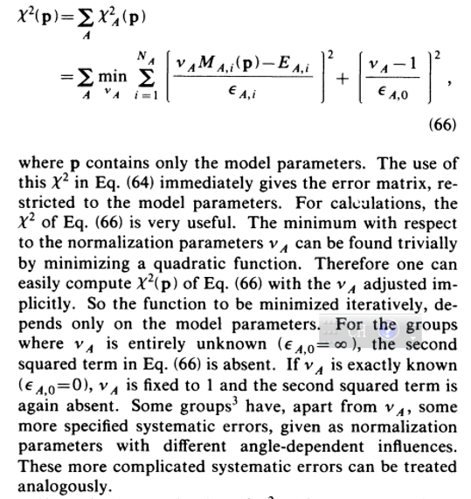

**The paper said, discussed above with A sample of the systematic errors, the normalized coefficient for argument =1±, the pull in depends on more parameters, since the researchers only interested in model parameters, by defining the following expression (66) to avoid this kind of trouble.**

According to the discussion in the original article, it can be seen that formula (66) is indeed an approximate expression, and there are the following problems. These questions are obtained from the analysis of the original text and are completely realistic conclusions without any exaggeration. Simply put, there are the following problems:

1. It is clearly stated in the text that this type of expression is used to avoid the trouble caused by the use of many parameters, but it is not mentioned whether the approximation satisfies the basic principles of mathematical statistics.

2. The text clearly states that such approximations are made because only the model parameters are of interest, which is one-sided for a complete data evaluation, which also depends on the error status of the experimental data base.

3. Normalization of the calculated values holds only when the statistical error is completely independent of the systematic error, which does not exist. The diagonal elements of the covariance matrix of experimental data are composed of statistical errors and systematic errors.

4. Only the diagonal elements of the covariance matrix of the experimental data are considered, and the contributions of statistical errors and systematic errors to are calculated separately. This inevitably leads to a drop in the correlation between statistical and systematic errors.

5. Deliberately underestimating the contribution of systematic errors to objectively or subjectively.

Please refer to the detailed description below.

1. In order to avoid the trouble caused by too many parameters, does the 'definition' of expression (66) have any scientific mathematical statistical basis? It is not mentioned at all, so that such definitions are 'subjective and arbitrary';

2. From the basic principle of mathematical statistics, 'only interested in determining model parameters' is one-sided approach, the correct expression of is not only related to' model parameters', but also related to how to deal with 'experimental data error'. It is not possible to get the correct model parameters without properly handling the 'error of experimental data'.

3. In the formula (66), by adjusting the coefficient of normalized argument to change calculated value (p) as the argument (p), so as to reduce the is A strange way, Normalization of the calculated values holds only when the statistical error is completely independent of the systematic error, which does not exist. this approach does not conform to the requirements of the 'maximum probable theory‘，that is in the ‘square expression’ of, molecular item must be 'actual calculated value’ minus the ‘actual used experimental value‘’, the denominator item must be the overall error. The actual calculated value corresponding to model parameters is (p), not (p).The final calculated value must be (p), so the final real is not about 1, but something greater than 1.

4. Any experimental data contains statistical error and systematic error, and the statistical error and systematic error are related, this correlation has a great impact on the optimization of . In Formula (66)，the first square item represent the contribution form statistical error (), the second square item represent the contribution of system error (), no the item which represent the contribution from the correlation of statistical error and system error. Therefore, the obtained by formula (66) will deviate from the real , and the model parameter set obtained by formula (66) will deviate from the optimal parameter set. The calculated values of the model obtained by formula (66) will deviate from the unbiased estimate.

5. Generally speaking, the number of measured data points of the angular distribution of an energy point is much larger than 1. Taking the proton-proton scattering Angle distribution below 51 MeV as an example, the angular distribution of 54 energy points can be used, with a total of 1620 data points, with an average of 28 data points per energy point. In Formula (66), for each energy point, the contribution of statistical error to was taken into account for each data, while the contribution of systematic error to was taken into account only once. In fact, the total error of each data point is composed of statistical error and systematic statistical error, often the systematic error is larger than the statistical error, so relative to the statistical error, formula (66) **seriously underestimates the contribution of systematic error to .**

6. Also in the formula (66), when an experiment did not give a systematic error, then to assume the system error is infinite (=∞), so that the second item is 0, when given an accurate system error then to assume the argument =1, so the second item is 0. Such a setting is physically and mathematically unreasonable. Generally speaking, if an experiment does not give a systematic error, it is a relative measured value. If its angular distribution is of good shape and energy points are indispensable, it can be adopted after normalization processing, which is of great significance for improving the reliability of data fitting. According to the error propagation theorem, such data will make a relatively large contribution to the chi-squared, rather than no contribution. Generally speaking, if an accurate system error were given in the experiment, namely value is much smaller, mathematically speaking, is very sensitive for the second item [(-1)/] 2 and often has significant contribution to , rather than did not. Therefore, **the treatment of systematic error in this paper is to artificially reduce the contribution of systematic error to** .

7. Finally a conclusion is that the expression of (66) does not conform to the basic principle of mathematical statistics, and the model parameters and evaluation value obtained will be unreliable.

The expression of Nijmegen group has great influence in the field of nucleon-nucleus scattering, and correcting its errors is of great academic significance in the field of few-body scattering.

**B. GLS has a high sensitivity to χ2, which is conducive to obtaining the best normalization coefficient;**

Practice shows that if the covariance matrix of the experimental data set is adopted in GLS, PPP is likely to occur if the systematic error is greater than 30% of the statistical error, and the value of is relatively large. This strongly requires that the evaluators must do a good job in normalization and minimize the systematic error of actual use after correction, so as to avoid PPP and make close to 1. If an approximate least squares ALS is used, using only the diagonal elements of the covariance matrix of the experimental data set, PPP will not occur regardless of how large the systematic errors are, and it is relatively easy to let close to one. For example, if an experimental data set has 30 data points, the average statistical error is 4%, and the actual systematic error is +6%. If GLS is adopted, the summation of will involve 30×30 matrix elements. Only when the adjusted normalization coefficient is close to 0.95 can PPP be avoided and be close to 1. The corrected systematic error actually used at this time is +1%. When ALS is adopted, the summation of involves 31 computational elements, 30 from statistical errors and one from systematic errors. When the normalized coefficient is close to 0.97, it is possible to get close to 1.0, when the actual corrected systematic error used is +3%. Therefore, it is possible to use GLS to make the normalized experimental data set closer to the expected value.

If a set of data is subject to precise normalization, the systematic error in the actual data will be significantly less than the statistical error, and PPP will naturally disappear.

**C. How to do systematic error correction, how to do error correction for certain angles and error correction for certain energy points;**

Incident particle sources, detectors and data acquisition systems, etc., will produce different systematic errors at different energies, and also at different angles. If an experimental data set involves a lot of energy points and a lot of angles, you need to make angle-related corrections as well as energy-related corrections. Such corrections are made using iterative processes and changing experimental data sets. When making energy-related corrections, the angular distribution of different energy points is used, and a normalization factor is used for one energy point or several adjacent energy points, and the appropriate normalization factor is found through the χ2 optimization process. After that, the corrected angular distribution of different energy points is converted into an 'excitation function' for a certain detection Angle, that is, the energy distribution with respect to a certain Angle. The new experimental data set is used to make corrections related to angles. A normalization factor is used for one Angle or several adjacent angles, and the appropriate normalization factor is found through the optimization process. A relatively satisfactory set of data fitting and normalization factors can be obtained through several iterations.

**D. The revised experimental data set, including principal values and errors, should be used in the iterative process;**

Experimental data bases for a nuclear system often contain many groups of experimental data, of the following types in terms of principal values and errors:

D1. Relative measurement data, containing only relative values and statistical errors. This kind of data is more abundant, if its shape is reasonable should be used. It can be normalized according to the existing evaluation values to give preliminary principal values and systematic errors.

D2. Absolute measurement data, but no systematic errors are given, only principal values and statistical errors are included. This kind of data is also relatively large, if its shape is reasonable should be used. Preliminary systematic errors can be given based on the available evaluation values.

D3. Absolute measurement data, containing principal values, statistical errors and systematic errors, usually occupy the majority of such data, but the systematic errors of some data sets are relatively large, and may be greater than the statistical errors.

The original parameters and the experimental data base are normalized by using the iterative process, automatic adjustment of R-matrix parameters and normalized coefficients. After the completion of each iterative process, the experimental data base needs to be updated, and the new principal value and error information are used to start the new iterative process. The experimental value used for the actual fitting must certainly be the corrected experimental value, and it is not reasonable to continue to use the old error information.

**E. The original error or corrected error of the data set can be used to calculate the covariance of the evaluation value finally;**

The covariance matrix of the intermediate fit values can be calculated using the error propagation theorem during the fitting process, and its diagonal elements are the standard error values. The relative error can be obtained by using the standard error value and the intermediate fitting value. Generally, the relative error is about 0.2% to 2%, which is significantly smaller than the relative statistical error and closer to the systematic error used in practice. The actual used systematic errors are difficult to obtain using the normalized coefficients, and **perhaps the standard error values of the intermediate fitted values can be used as systematic errors.** In the final calculation of the covariance matrix of the evaluation value, the original error or the corrected error of the data set can be used, and the corrected error can be expressed by the normalized coefficient, or the standard error value of the final fitted value can be used. The covariance matrix obtained by these three types of calculation methods will be significantly different. In principle, it is reasonable to use the corrected error to participate in the calculation.

**F. The error calculated by the error transfer formula is significantly different from the error calculated by the Monte Carlo method**

It is very difficult to judge whether the covariance matrix of evaluation values is reasonable. However, for the diagonal elements-standard errors, we can qualitatively study whether they are reasonable according to the basic characteristics of mathematical statistical analysis. One feature is that the smaller the error of the experimental data is, the smaller the standard error of the corresponding evaluation value is. The other feature is that in a certain energy region, the larger the density of the data points is, the smaller the standard error of the corresponding evaluation value is.

For example, in the 12C (α, γ) 16O experimental data base, the experimental data points are very dense and the error is minimal near the first resonance peak 1-1 (E=2.2 to 2.4 MeV). There are no experimental data in the low-energy region (E<0.8 MeV), where only four bound states are at work. Figure 1 below shows the results of the RAC analysis. RAC uses the error transfer formula to calculate the covariance matrix of the evaluation values, and Figure 1 shows the evaluation values and corresponding standard errors of various S-factors. It can be seen that the standard error in the E=2.2 to 2.4 MeV energy region (the Stot mean is 0.8%) is significantly smaller than the standard error in the E<0.8 MeV energy region (the Stot mean is 5%), which is reasonable. Figure 2 shows the analysis results in AZURE2017 (Rev. Mod. Phys. 89, 035007 (2017)), **the error of S factor as derived by combine the MC analysis and the model error.** It can be seen that the standard errors and reaction rates in the E=2.2 to 2.4 MeV energy region are very close to the corresponding values in the E<0.8 MeV energy region, which is not easy to explain.

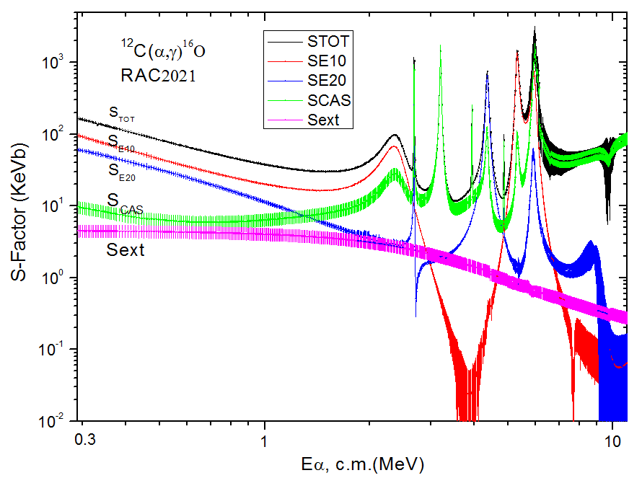 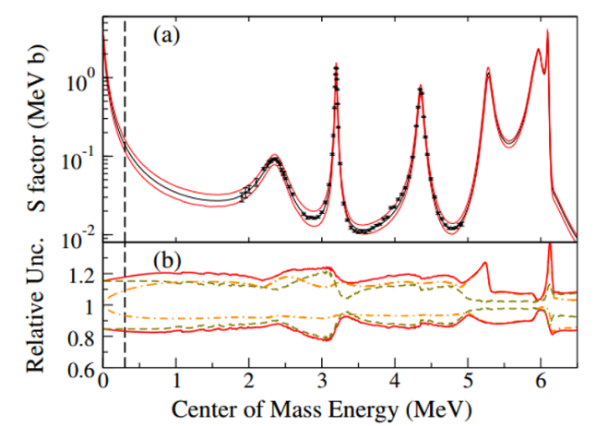

FIG. 1. Evaluated S factors and their Standard Deviation Fig. 2. The FIG. 25 of AZURE2017, the error of

for 12C (α, γ) 16O at 660 energies in c.m. system, S factor as derived by combine the MC analysis

is the total contribution of background levels. and the model error.

**G. The total reduced channel width parameter Γ can be flexibly applied to multiple classes;**

Using the reduced R-matrix theory, it is possible to extend the analytical energy region to high energy, which can be used to represent different physical quantities in different nuclear systems. For example, nuclear reaction channels with three or more bodies, high level inelastic scattering or total contribution of reaction cross sections, reaction channels without experimental data, etc. In theory, this is an approximate method, but if used properly, it can meet the needs of phenomenological fitting. This is an attempt to complete the evaluation of the entire analytical energy region for a single nuclear system **using only one class of models.**

**H. RAC determines the energy level parameters used by fitting the experimental data, and finally calculates the evaluation value by using the best parameter set, while the statistical model calculates the evaluation value by the given energy level parameters.**

At present, the evaluation value of some light nuclei is obtained by using statistical models in the region of indistinctable resonance energy levels. Therefore, the RAC analysis method has some common characteristics with the statistical model, which is to calculate the reaction cross section through the energy level. However, RAC determines the energy level parameters used by fitting experimental data, and finally calculates the evaluation value by using the best parameter set, while statistical model calculates the evaluation value by using the given energy level parameters. In the iterative process of RAC fitting experimental data, the set containing all energy levels is adopted, and there is no a priori restriction on the number, position and width of energy levels. The sensitivity of each energy level to can be observed in the process of optimizing , the very insensitive energy levels can be removed, and the energy levels that need to be added in order to improve the fit can be added. The improved parameter set can be obtained in the next iteration process.

**I. If the fitting procedures of different models are adopted, the calculation results are difficult to be repeated with each other.** As long as four significant digits of the main calculated values are consistent, the requirements of phenomenological fitting can be met. As long as the evaluation results of different Codes are close to each other, it is ok. For example, fifty students using the same optical model formula and parameters, through their own programming and calculation of a certain type of nuclear reaction cross section, will get fifty slightly different results, they may have more than five significant digits are consistent, these results are acceptable, but it is difficult to determine which result is the most accurate.

**J. Do the ALS，CLS and GLS methods give the same results, or different?**

In general, RAC uses CLS to analyze experimental data, using the covariance matrix V of experimental data, requiring that the experimental data set be normally distributed and the covariance matrix be positive definite. If you drop the off-diagonal elements of V, it becomes ALS.

**CLS： minimum，**

After using CLS to obtain a relatively satisfactory fit, GLS can be further used to fit the data-base.

**GLS： minimum，**

In the expression of GLS above, in the first part is the parameters obtained by CLS, is the corresponding covariance matrix, the second part is the original data base same as that used in CLS. **At this point the requirement that the experimental data set must be** normally distributed **in CLS can be relaxed**. Then keep going to search parameters from . The I represents the contribution from the first part, and the T represents total ,which are shown in Appendix 3, when adjusting all parameter one by one separately. In Appendix 3, it can be seen that I changes in an oscillatory manner, and T is steadily and gradually smaller from 9584.05957 to 9233.25391.

**Appendix 3. I of the first part and the corresponding total T**

**when adjusting one parameter one by one separately (selected)**

**I  -- T I  -- T I  -- T I  -- T**

0.07452--9584.05957 18.49068--9633.88574 10.40776--9572.29395 21.70643--9576.42773

..........................................................................................................................................................................

36.09614--9425.55078 36.27035--9426.07715 36.10312--9425.55566 36.75064--9425.58594

..........................................................................................................................................................................

8.66492--9257.14453 8.60890--9256.06055 8.52905--9256.03320 8.76310--9255.96777

..........................................................................................................................................................................

4.53774--9240.98633 5.53692--9240.11719 5.45762--9240.11523 5.49306--9240.29297

..........................................................................................................................................................................

43.66846--9286.51172 3.30768--9233.29199 3.99469--9233.94629 3.32357--9233.25391

Appendix 2. Some information about the experimental data **(selected)**

A—Parameter serial number; Group—Author; NF-Final norm. NJ-Norm. used for search in fitting;

CO- Block mean search, other mean no search; Step- The step size of the parameter change;

Wei- Weight factor; -ALS – of ALS; -GLS of GLS; Nu- Number of data points

A Group NF NJ CO Step Wei -ALS -GLS /  / Nu

1 'PPDAa035' 0.9323 1.0000 ‘N’ 1.0 1.0000 1.3737 1.5155 -0.0667 -0.0666 27

2 'PPDAa041' 0.9356 1.0000 ‘N’ 1.0 1.0000 1.2922 1.3081 -0.0634 -0.0634 27

...................................................................................................................................................................

79 'PPDAsk11' 1.2085 1.0000 ‘N’ 1.0 1.0000 0.7268 0.7289 0.2095 0.2095 30

80 'PPDAmere' 1.0514 1.0000 ‘N’ 1.0 1.0000 1.1423 1.6017 0.0524 0.0525 26

81 'PHCSfied' 1.1011 1.0000 ‘N’ 1.0 1.0000 0.1438 0.1448 0.1021 0.1021 6

82 'PHCSgeme' 0.7298 1.0000 ‘N’ 1.0 1.0000 0.5078 0.5294 -0.2692 -0.2692 15

...................................................................................................................................................................

121 'PHDAl145' 0.9782 1.0000 ‘N’ 1.0 1.0000 1.8342 2.1473 -0.0208 -0.0208 17

122 'PHDAl156' 0.9607 1.0000 ‘N’ 1.0 1.0000 3.0339 3.5465 -0.0383 -0.0383 17

123 'PHAYbr29' 0.7025 1.0000 ‘N’ 1.0 1.0000 0.7070 0.7120 -0.2965 -0.2965 4

...................................................................................................................................................................

134 'PHAYb149' 0.8415 1.0000 ‘N’ 1.0 1.0000 0.4483 0.4561 -0.1575 -0.1575 6

135 'PHDAb167' 1.4687 1.0000 ‘N’ 1.0 1.0000 0.4232 0.4282 0.4697 0.4698 30

136 'PHDAgou1' 0.7606 1.0000 ‘N’ 1.0 1.0000 2.9762 2.5911 -0.2384 -0.2384 14

...................................................................................................................................................................

146 'PHDAgu08' 0.6917 1.0000 ‘N’ 1.0 1.0000 0.4985 0.5326 -0.3073 -0.3073 17

147 'PHDAgu10' 0.8767 1.0000 ‘N’ 1.0 1.0000 0.7997 0.8215 -0.1223 -0.1223 18

148 'PP1CShar' 1.0000 1.0000 ‘z’ 1.0 1.0000 2.9560 1.8141 0.0010 0.0010 12

...................................................................................................................................................................

154 'PP1Dgou3' 0.5916 1.0000 ‘N’ 1.0 1.0000 1.1332 1.1791 -0.4074 -0.4074 25

155 'PP2Charr' 1.0000 1.0000 ‘z’ 1.0 1.0000 0.8693 1.0937 0.0010 0.0010 50

...................................................................................................................................................................

158 'PP2Dmere' 1.0000 1.0000 ‘z’ 1.0 1.0000 0.5017 0.5317 0.0010 0.0010 20

159 'PG0Cswit' 1.0000 1.0000 ‘z’ 1.0 1.0000 1.0550 1.1092 0.0010 0.0010 9

...................................................................................................................................................................

163 'PG1Dosto' 0.7028 1.0000 ‘N’ 1.0 1.0000 0.9317 0.9740 -0.2962 -0.2962 8

164 'HHDAmo34' 0.9343 1.0000 ‘N’ 1.0 1.0000 0.5246 0.5412 -0.0647 -0.0647 4

165 'HHDAmo40' 1.0131 1.0000 ‘N’ 1.0 1.0000 2.1529 2.2827 0.0141 0.0141 10

...................................................................................................................................................................

221 'HHDAja28' 0.9768 1.0000 ‘N’ 1.0 1.0000 0.9515 0.9110 -0.0222 -0.0223 38

222 'HHDAja30' 1.1129 1.0000 ‘N’ 1.0 1.0000 0.7007 0.7053 0.1139 0.1138 38

223 'HHAYbo72' 0.8021 1.0000 ‘N’ 1.0 1.0000 2.9570 2.7932 -0.1969 -0.1969 13

...................................................................................................................................................................

228 'HHAYh114' 1.0703 1.0000 ‘N’ 1.0 1.0000 1.2338 1.2344 0.0713 0.0713 12

229 'HP1Dspig' 0.3185 1.0000 ‘N’ 1.0 1.0000 0.6378 0.6818 -0.6805 -0.6805 18

230 'HP1Dspi1' 0.3491 1.0000 ‘N’ 1.0 1.0000 0.5967 0.6203 -0.6499 -0.6499 18

231 'HG0Cosbo' 1.0000 1.0000 ‘z’ 1.0 1.0000 0.2104 0.2100 0.0010 0.0010 16

232 'HG0Csing' 1.0000 1.0000 ‘z’ 1.0 1.0000 0.6885 0.7787 0.0010 0.0010 24

233 'HG1Cosbo' 1.0000 1.0000 ‘z’ 1.0 1.0000 0.3543 0.3683 0.0010 0.0010 16

234 'HG1Csing' 1.0000 1.0000 ‘z’ 1.0 1.0000 0.6768 0.7808 0.0010 0.0010 24

235 'HPDAsp25' 0.7299 1.0000 ‘N’ 1.0 1.0000 0.5576 0.5977 -0.2691 -0.2691 23

...................................................................................................................................................................

248 'HPDAsp28' 0.7722 1.0000 ‘N’ 1.0 1.0000 1.9313 2.1834 -0.2268 -0.2269 26

249 'HPDAsp56' 0.8774 1.0000 ‘N’ 1.0 1.0000 1.9197 1.2288 -0.1216 -0.1215 53

In Appendix 2, NF denotes the final normalized coefficient. -ALS - denotes the of ALS; -GLS represents the of GLS. If the difference between the two values is very large, the normalization process needs to be continued; if the difference between the two values is not large, the normalization process no longer needs to be continued. If -ALS and -GLS are closed, then the evaluation values of ALS, CLS and GLS will have a little differences. But the covariance matrix of evaluation values of them will have rather lager differences.

**K. How to evaluate the reliability of system-wide data fitting;**

People usually use the average to judge the reliability of data fitting, which is an important basis. Since different works use different expressions, the quality of the fit cannot be judged only by the magnitude of . There are many groups of experimental data involved in the whole system data fitting, and each group of experimental data needs to be normalized. Therefore, it is very important to show the fitting status of each group of experimental data with very clear graphics. In each plot, it is best to show the original data, the normalized data, and the fitted values, which is very necessary to judge the quality of the fit. In the iterative fitting process, such graphs can be used to find areas that need improvement. The following comparison chart shows two examples.

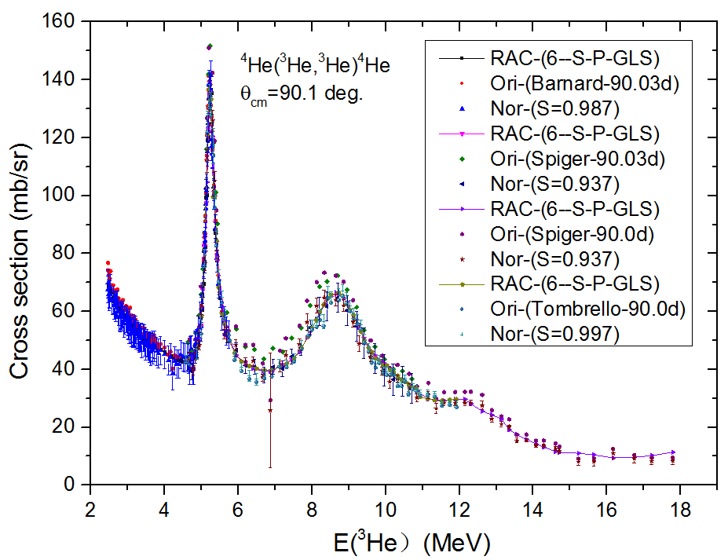

**L. The documentation of the evaluation library can be in the format used by SAMMY for light uncles, that is, to publish the calculated values of various sections rather than parameters. Let's say n + 35Cl.**

The lower left panel shows the integrated cross section of n + 35Cl in the low energy region, and the right panel shows the total cross section of n + *35*Cl in ENDF/B VIII.0.

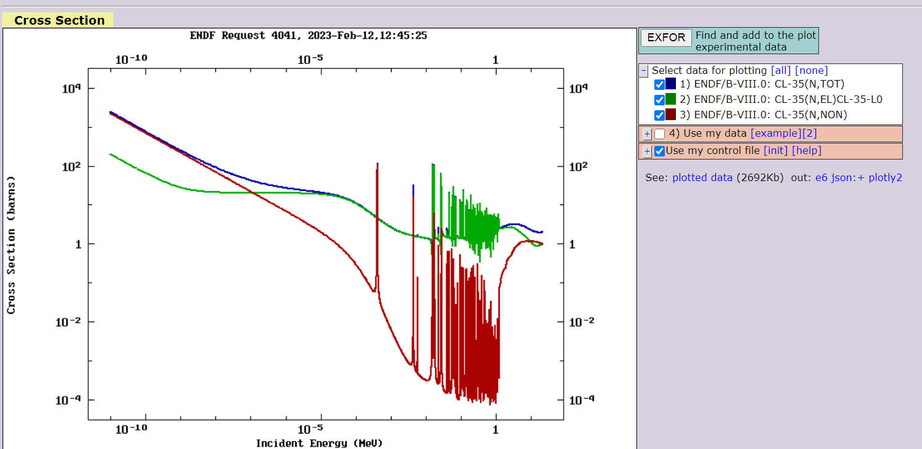 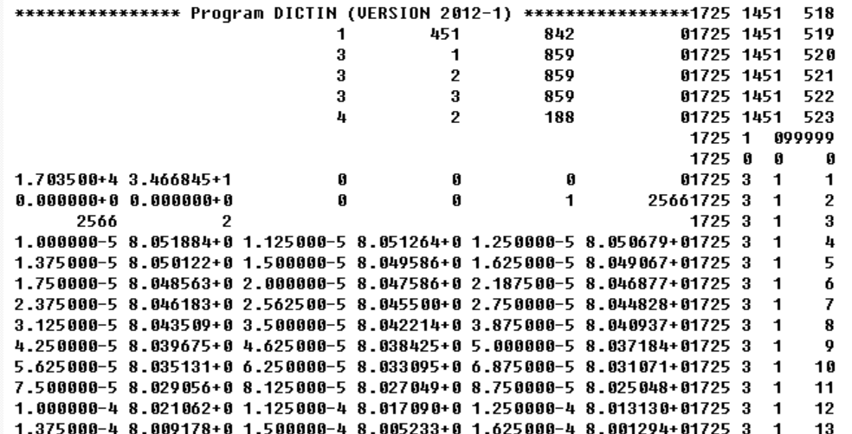

**Thanks for your advice!**

**III. Appendix**

**Appendix 1：Table 1. Representative expression of χ2 between 1956 and 2019**

|  |  |  |  |  |  |  |
| --- | --- | --- | --- | --- | --- | --- |
| * Date of * Publica- * tion; * Date of * use | * Least squares type; * Calculation model; * Computer programs; * Reference number. | The expression of*χ*2 used,  where  represents the  experimental data;  s the calculated value;  is experiment data error; | Whether  or not  consider  [correlation](javascript:;)  of errors | How to do  Experimental data  Normalized treatment | * How to deal with unfitted experimental data | Analysis function;  The results of the analysis;  About the comments |
| 1956-  1987 | Ordinary Least-Squares;  Phase shift analysis [1] | *χ*2=   * N: Experimental data points | No | / | / | * Pioneering work |
| 1988-  2020 | Approximate least squares;  Phase shift analysis [2,3];  AV18 potential [4];  The CD - Bonn potential [5]  ] | + ,  A: A subset of experimental data;  : The normalization coefficient of subset;  : The number of data points in a subset;  : the statistical error of data points;  : A subset of the system error; | No | A. Change the calculation value  to reduce the chi-square value of 2;  B. Deliberately reduce the chi-square of  systematic errors | Rejected the experimental data points  1460  with 2.>9 | A phase shift analysis [2,3] is considered to be abrupt Destructive work; Although the author thinks that the phase shift is not accurate enough;  B. AV18 potential is considered to be a flow  Line and universal selection [10];  C. CD-Bonn is considered the most sophisticated;  D. No error estimation of potential parameters [11];  E. AV18 potential is used in nuclear structure calculation, resulting  Its energy dependence becomes very bad [11]; |
| 2001-  2020 | Approximate least squares;  R-matrix model;  Program EDA [6];  The United States | =  i: Data number for a subset,  s: Systematic error | No | Changes in computing  Value to minimize  χ2 | b. Rejected the experimental data points  with 2.>16 | Evaluate light  Nuclear data; |
| 2004-  2020 | Approximate least squares;  R-matrix model;  Program AZURE[7];  The United States | =+/)  =(*y*()-)/()  *y*() is theory fitting values,  is the data values,  is statistical error,  is system error. | No | Changes in computing  Value to minimize  χ2 | Do the normalized | Astro-nuclear physics |
| 2008 | Approximate least squares;  Covariant spectator  theory(CST),  [8] | =  +(1 - n)2/(*n*)2 | No | A. Change the data value  to reduce the chi-square value of 2;  B. Deliberately reduce the chi-square of  systematic errors | a Do the normalized  b. Rejected the experimental data points 1460  with 2.>9 |  |
| 2017 | Ordinary Least-Squares;  Test Normality of residuals for the data  Set (N = 6713)  [9] |  | No |  | Rejected the experimental data points  with 2.>9 |  |
| 2019 | Ordinary Least-Squares;  N-N potential;  [comprehensive](javascript:;)  [survey](javascript:;) (10) | *χ*2= | No | / | ejected the experimental data points  with 2.>9 more than 1460. |  |
| 2004-  2020 | Reduced R- matrix;  RAC (11,12);  China  A General least squares;  B Conventional least squares;  C. Approximate least squares; | =+/)  =(*y*()-)/() | Consider  the correlation of  statistical  error  With the system  error | A. Do your homework first  Preprocessing of experimental data;  B. Correction of errors  Large experimental  Value to reduce the chi-squared | a. normalized experimental data  b Magnify the error, making  Deviation from the average  Three times the variance. | The reduced R- matrix theory is adopted；  Nuclear data evaluation program,  First of all, using approximate least squares,  Or conventional least squares;  Finally using Generalized least squares |

**Appendix 2. Some information about the experimental data**

A—Parameter serial number;; Group—Author; NF-Final norm. NJ-Norm. for search in fitting;

CO- Block mean search, other mean no search; Step- The step size of the parameter change;

Wei- Weight factor; -ALS – of ALS; -GLS of GLS; Nu- Number of data points

A Group NF NJ CO Step Wei -ALS -GLS /  / Nu

1 'PPDAa035' 0.9323 1.0000 ‘N’ 1.0 1.0000 1.3737 1.5155 -0.0667 -0.0666 27

2 'PPDAa041' 0.9356 1.0000 ‘N’ 1.0 1.0000 1.2922 1.3081 -0.0634 -0.0634 27

3 'PPDAa046' 0.8958 1.0000 ‘N’ 1.0 1.0000 1.2395 1.2929 -0.1032 -0.1032 31

4 'PPDAa052' 0.9588 1.0000 ‘N’ 1.0 1.0000 0.7100 0.7355 -0.0402 -0.0401 28

5 'PPDAa057' 0.9296 1.0000 ‘N’ 1.0 1.0000 0.9175 0.9429 -0.0694 -0.0695 31

6 'PPDAa063' 0.9160 1.0000 ‘N’ 1.0 1.0000 1.3769 1.4153 -0.0830 -0.0830 29

7 'PPDAa068' 0.8582 1.0000 ‘N’ 1.0 1.0000 0.6930 0.7538 -0.1408 -0.1408 9

8 'PPDAa074' 0.9596 1.0000 ‘N’ 1.0 1.0000 1.5449 1.6678 -0.0394 -0.0393 9

9 'PPDAa079' 0.8892 1.0000 ‘N’ 1.0 1.0000 0.7073 0.6816 -0.1098 -0.1099 35

10 'PPDAa084' 1.0119 1.0000 ‘N’ 1.0 1.0000 1.6177 1.6534 0.0129 0.0129 32

11 'PPDAa090' 0.9191 1.0000 ‘N’ 1.0 1.0000 1.5588 1.4884 -0.0799 -0.0799 30

12 'PPDAa095' 0.9108 1.0000 ‘N’ 1.0 1.0000 0.6405 0.6509 -0.0882 -0.0883 34

13 'PPDAa100' 0.9344 1.0000 ‘N’ 1.0 1.0000 0.8406 0.8455 -0.0646 -0.0646 34

14 'PPDAa105' 0.9466 1.0000 ‘N’ 1.0 1.0000 0.9687 0.9988 -0.0524 -0.0524 35

15 'PPDAa110' 1.0074 1.0000 ‘N’ 1.0 1.0000 0.8318 0.8691 0.0084 0.0084 35

16 'PPDAa114' 0.9775 1.0000 ‘N’ 1.0 1.0000 1.0982 1.1241 -0.0215 -0.0215 37

17 'PPDAa119' 0.9858 1.0000 ‘N’ 1.0 1.0000 1.4280 1.3737 -0.0132 -0.0133 36

18 'PPDAa124' 0.9261 1.0000 ‘N’ 1.0 1.0000 1.0420 1.0694 -0.0729 -0.0729 36

19 'PPDAa128' 0.9452 1.0000 ‘N’ 1.0 1.0000 0.6527 0.6740 -0.0538 -0.0538 37

20 'PPDAa133' 0.9452 1.0000 ‘N’ 1.0 1.0000 1.0642 1.0863 -0.0538 -0.0538 35

21 'PPDAa137' 0.8918 1.0000 ‘N’ 1.0 1.0000 1.0198 1.0376 -0.1072 -0.1072 34

22 'PPDAa142' 0.9081 1.0000 ‘N’ 1.0 1.0000 2.1415 2.1293 -0.0909 -0.0908 32

23 'PPDAa146' 0.9650 1.0000 ‘N’ 1.0 1.0000 1.1561 1.0523 -0.0340 -0.0340 37

24 'PPDAa151' 0.9645 1.0000 ‘N’ 1.0 1.0000 1.1492 1.1585 -0.0345 -0.0345 34

25 'PPDAa155' 0.9839 1.0000 ‘N’ 1.0 1.0000 0.7804 0.7881 -0.0151 -0.0151 37

26 'PPDAa159' 0.9700 1.0000 ‘N’ 1.0 1.0000 0.8966 0.8526 -0.0290 -0.0290 35

27 'PPDAa163' 0.9697 1.0000 ‘N’ 1.0 1.0000 1.2659 1.1934 -0.0293 -0.0293 32

28 'PPDAa168' 0.9801 1.0000 ‘N’ 1.0 1.0000 1.3349 1.1412 -0.0189 -0.0189 33

29 'PPDAmc70' 1.0181 1.0000 ‘N’ 1.0 1.0000 2.2680 2.2615 0.0191 0.0191 21

30 'PPDAmc90' 0.9980 1.0000 ‘N’ 1.0 1.0000 0.1215 0.1220 -0.0010 -0.0009 21

31 'PPDAm110' 0.9457 1.0000 ‘N’ 1.0 1.0000 1.2201 1.2399 -0.0533 -0.0533 21

32 'PPDAm125' 0.9277 1.0000 ‘N’ 1.0 1.0000 0.6281 0.6391 -0.0713 -0.0713 21

33 'PPDAm140' 0.9194 1.0000 ‘N’ 1.0 1.0000 1.3053 1.3322 -0.0796 -0.0796 21

34 'PPDAm160' 0.9301 1.0000 ‘N’ 1.0 1.0000 0.9514 0.9690 -0.0689 -0.0689 22

35 'PPDAfa54' 1.0019 1.0000 ‘N’ 1.0 1.0000 1.1575 1.2034 0.0029 0.0030 11

36 'PPDAfa69' 0.9145 1.0000 ‘N’ 1.0 1.0000 0.2333 0.2450 -0.0845 -0.0845 11

37 'PPDAfa89' 0.8925 1.0000 ‘N’ 1.0 1.0000 0.8676 0.9146 -0.1065 -0.1065 11

38 'PPDAf109' 0.9157 1.0000 ‘N’ 1.0 1.0000 1.0280 1.0713 -0.0833 -0.0833 11

39 'PPDAf124' 0.9066 1.0000 ‘N’ 1.0 1.0000 0.9568 0.9966 -0.0924 -0.0924 11

40 'PPDAf140' 0.9180 1.0000 ‘N’ 1.0 1.0000 0.4454 0.4623 -0.0810 -0.0810 11

41 'PPDAf149' 0.9197 1.0000 ‘N’ 1.0 1.0000 0.3363 0.3477 -0.0793 -0.0793 11

42 'PPDAf165' 0.9399 1.0000 ‘N’ 1.0 1.0000 0.9401 0.9930 -0.0591 -0.0591 11

43 'PPDAmcc0' 1.0000 1.0000 ‘z’ 1.0 1.0000 9.3554 3.5082 0.0010 0.0010 68

44 'PPDAmcc1' 0.9433 1.0000 ‘N’ 1.0 1.0000 1.4723 1.4824 -0.0557 -0.0557 68

45 'PPDAmcc2' 0.9125 1.0000 ‘N’ 1.0 1.0000 2.4629 2.6007 -0.0865 -0.0865 73

46 'PPDAmcc3' 0.9354 1.0000 ‘N’ 1.0 1.0000 1.9535 1.8776 -0.0636 -0.0636 73

47 'PPDAha39' 0.9304 1.0000 ‘N’ 1.0 1.0000 2.4486 2.6498 -0.0686 -0.0687 9

48 'PPDAha54' 0.9012 1.0000 ‘N’ 1.0 1.0000 1.8418 1.9906 -0.0978 -0.0978 17

49 'PPDAha63' 0.8857 1.0000 ‘N’ 1.0 1.0000 1.1709 1.1994 -0.1133 -0.1133 24

50 'PPDAha73' 0.8739 1.0000 ‘N’ 1.0 1.0000 1.1245 1.1811 -0.1251 -0.1251 12

51 'PPDAha80' 0.8946 1.0000 ‘N’ 1.0 1.0000 1.0636 1.2012 -0.1044 -0.1044 25

52 'PPDAha90' 0.9229 1.0000 ‘N’ 1.0 1.0000 1.1968 1.3435 -0.0761 -0.0761 32

53 'PPDAha99' 0.9375 1.0000 ‘N’ 1.0 1.0000 1.3689 1.4990 -0.0615 -0.0615 25

54 'PPDAh109' 0.9485 1.0000 ‘N’ 1.0 1.0000 1.1624 1.2381 -0.0505 -0.0505 14

55 'PPDAh116' 0.9474 1.0000 ‘N’ 1.0 1.0000 0.8669 0.8921 -0.0516 -0.0516 25

56 'PPDAh125' 0.9585 1.0000 ‘N’ 1.0 1.0000 0.5624 0.5795 -0.0405 -0.0405 32

57 'PPDAh132' 0.9462 1.0000 ‘N’ 1.0 1.0000 1.2252 1.2948 -0.0528 -0.0528 10

58 'PPDAh140' 0.9414 1.0000 ‘N’ 1.0 1.0000 0.6554 0.7064 -0.0576 -0.0575 25

59 'PPDAh150' 0.9303 1.0000 ‘N’ 1.0 1.0000 0.8653 0.9129 -0.0687 -0.0687 15

60 'PPDAh163' 0.9538 1.0000 ‘N’ 1.0 1.0000 0.8097 0.8579 -0.0452 -0.0452 25

61 'PPDAfas1' 0.8728 1.0000 ‘N’ 1.0 1.0000 2.9349 3.1090 -0.1262 -0.1262 30

62 'PPDAfas2' 0.7910 1.0000 ‘N’ 1.0 1.0000 1.0092 1.0940 -0.2080 -0.2080 32

63 'PPDAfas3' 0.6985 1.0000 ‘N’ 1.0 1.0000 0.2666 0.2606 -0.3005 -0.3005 53

64 'PPDAfas4' 0.8150 1.0000 ‘N’ 1.0 1.0000 0.7520 0.7624 -0.1840 -0.1841 58

65 'PPDAfas5' 0.8137 1.0000 ‘N’ 1.0 1.0000 1.3152 1.3776 -0.1853 -0.1918 57

66 'PPDAfas6' 0.8382 1.0000 ‘N’ 1.0 1.0000 2.7920 2.9193 -0.1608 -0.1608 58

67 'PPDAfas7' 0.8146 1.0000 ‘N’ 1.0 1.0000 1.3988 1.4338 -0.1844 -0.1843 60

68 'PPDAfas8' 0.8467 1.0000 ‘N’ 1.0 1.0000 1.5740 1.5484 -0.1523 -0.1523 58

69 'PPDAskl1' 0.9482 1.0000 ‘N’ 1.0 1.0000 2.0846 2.0875 -0.0508 -0.0508 20

70 'PPDAskl2' 1.0380 1.0000 ‘N’ 1.0 1.0000 2.7684 2.7734 0.0390 0.0389 20

71 'PPDAskl3' 0.9229 1.0000 ‘N’ 1.0 1.0000 0.8202 0.8200 -0.0761 -0.0760 20

72 'PPDAskl4' 1.3618 1.0000 ‘N’ 1.0 1.0000 0.3038 0.3063 0.3628 0.3629 20

73 'PPDAskl5' 1.2167 1.0000 ‘N’ 1.0 1.0000 0.7055 0.7095 0.2177 0.2177 20

74 'PPDAskl6' 1.1165 1.0000 ‘N’ 1.0 1.0000 2.8692 2.8734 0.1175 0.1175 20

75 'PPDAskl7' 0.9999 1.0000 ‘N’ 1.0 1.0000 0.9288 0.9431 0.0009 0.0009 10

76 'PPDAskl8' 1.2567 1.0000 ‘N’ 1.0 1.0000 0.4008 0.4030 0.2577 0.2577 10

77 'PPDAskl9' 1.3486 1.0000 ‘N’ 1.0 1.0000 0.2995 0.3000 0.3496 0.3496 10

78 'PPDAsk10' 1.0659 1.0000 ‘N’ 1.0 1.0000 0.8887 0.8926 0.0669 0.0669 10

79 'PPDAsk11' 1.2085 1.0000 ‘N’ 1.0 1.0000 0.7268 0.7289 0.2095 0.2095 30

80 'PPDAmere' 1.0514 1.0000 ‘N’ 1.0 1.0000 1.1423 1.6017 0.0524 0.0525 26

81 'PHCSfied' 1.1011 1.0000 ‘N’ 1.0 1.0000 0.1438 0.1448 0.1021 0.1021 6

82 'PHCSgeme' 0.7298 1.0000 ‘N’ 1.0 1.0000 0.5078 0.5294 -0.2692 -0.2692 15

83 'PHCSelwy' 0.7693 1.0000 ‘N’ 1.0 1.0000 0.4682 0.4714 -0.2297 -0.2297 30

84 'PHCStumi' 0.7761 1.0000 ‘N’ 1.0 1.0000 0.4576 0.4589 -0.2229 -0.2228 29

85 'PHDAspig' 0.6955 1.0000 ‘N’ 1.0 1.0000 1.0505 1.0229 -0.3035 -0.3035 32

86 'PHDAkhan' 0.5407 1.0000 ‘N’ 1.0 1.0000 0.2038 0.2068 -0.4583 -0.4666 12

87 'PHDAkha1' 0.8237 1.0000 ‘N’ 1.0 1.0000 0.2137 0.2161 -0.1753 -0.1753 14

88 'PHDAbouc' 0.5764 1.0000 ‘N’ 1.0 1.0000 0.2208 0.2233 -0.4226 -0.4237 15

89 'PHDAbou1' 0.7995 1.0000 ‘N’ 1.0 1.0000 0.2546 0.2592 -0.1995 -0.1995 14

90 'PHDAel20' 0.6779 1.0000 ‘N’ 1.0 1.0000 0.5385 0.6802 -0.3211 -0.3211 18

91 'PHDAel30' 0.7478 1.0000 ‘N’ 1.0 1.0000 0.9239 1.0136 -0.2512 -0.2511 28

92 'PHDAel38' 0.7540 1.0000 ‘N’ 1.0 1.0000 1.1197 1.1460 -0.2450 -0.2450 29

93 'PHDAel48' 0.8053 1.0000 ‘N’ 1.0 1.0000 1.2089 1.2363 -0.1937 -0.1938 25

94 'PHDAel59' 0.8320 1.0000 ‘N’ 1.0 1.0000 1.9360 2.0214 -0.1670 -0.1670 26

95 'PHDAel70' 0.8419 1.0000 ‘N’ 1.0 1.0000 1.4057 1.5135 -0.1571 -0.1571 32

96 'PHDAel76' 0.8248 1.0000 ‘N’ 1.0 1.0000 2.6532 2.7260 -0.1742 -0.1742 25

97 'PHDAel86' 0.8471 1.0000 ‘N’ 1.0 1.0000 2.9333 3.0595 -0.1519 -0.1520 23

98 'PHDAel93' 0.8578 1.0000 ‘N’ 1.0 1.0000 2.0211 2.4266 -0.1412 -0.1413 15

99 'PHDAe102' 0.8651 1.0000 ‘N’ 1.0 1.0000 2.1230 2.2273 -0.1339 -0.1339 26

100 'PHDAe106' 0.8200 1.0000 ‘N’ 1.0 1.0000 1.2209 1.2925 -0.1790 -0.1789 28

101 'PHDAe118' 0.8484 1.0000 ‘N’ 1.0 1.0000 1.2932 1.3897 -0.1506 -0.1506 26

102 'PHDAe130' 0.8803 1.0000 ‘N’ 1.0 1.0000 1.8740 1.8311 -0.1187 -0.1188 30

103 'PHDAe141' 0.8866 1.0000 ‘N’ 1.0 1.0000 2.1932 1.3958 -0.1124 -0.1317 30

104 'PHDAe149' 0.9516 1.0000 ‘N’ 1.0 1.0000 1.8302 2.0499 -0.0474 -0.0473 21

105 'PHDAe156' 0.8316 1.0000 ‘N’ 1.0 1.0000 3.4141 3.0557 -0.1674 -0.1983 14

106 'PHDAli23' 0.7963 1.0000 ‘N’ 1.0 1.0000 0.4728 0.5357 -0.2027 -0.2027 11

107 'PHDAli28' 0.7981 1.0000 ‘N’ 1.0 1.0000 0.5393 0.5834 -0.2009 -0.2009 7

108 'PHDAli38' 0.8383 1.0000 ‘N’ 1.0 1.0000 0.9697 1.0287 -0.1607 -0.1607 16

109 'PHDAli52' 0.8762 1.0000 ‘N’ 1.0 1.0000 1.7713 1.9104 -0.1228 -0.1228 17

110 'PHDAli62' 0.8983 1.0000 ‘N’ 1.0 1.0000 2.3210 2.4835 -0.1007 -0.1007 18

111 'PHDAli74' 0.9487 1.0000 ‘N’ 1.0 1.0000 2.0851 2.1842 -0.0503 -0.0502 26

112 'PHDAli80' 0.9341 1.0000 ‘N’ 1.0 1.0000 1.7928 1.8900 -0.0649 -0.0649 16

113 'PHDAli86' 0.9388 1.0000 ‘N’ 1.0 1.0000 0.9995 1.0635 -0.0602 -0.0602 12

114 'PHDAli89' 0.9176 1.0000 ‘N’ 1.0 1.0000 1.3168 1.3932 -0.0814 -0.0814 13

115 'PHDAli94' 0.9062 1.0000 ‘N’ 1.0 1.0000 1.3361 1.3679 -0.0928 -0.0928 13

116 'PHDAli99' 0.8992 1.0000 ‘N’ 1.0 1.0000 0.7372 0.8034 -0.0998 -0.0998 16

117 'PHDAl105' 0.8956 1.0000 ‘N’ 1.0 1.0000 1.6329 1.6973 -0.1034 -0.1034 16

118 'PHDAl110' 0.8915 1.0000 ‘N’ 1.0 1.0000 1.9412 2.0768 -0.1075 -0.1076 12

119 'PHDAl121' 0.9573 1.0000 ‘N’ 1.0 1.0000 0.7228 0.7852 -0.0417 -0.0417 16

120 'PHDAl132' 0.9626 1.0000 ‘N’ 1.0 1.0000 2.2871 2.5238 -0.0364 -0.0364 17

121 'PHDAl145' 0.9782 1.0000 ‘N’ 1.0 1.0000 1.8342 2.1473 -0.0208 -0.0208 17

122 'PHDAl156' 0.9607 1.0000 ‘N’ 1.0 1.0000 3.0339 3.5465 -0.0383 -0.0383 17

123 'PHAYbr29' 0.7025 1.0000 ‘N’ 1.0 1.0000 0.7070 0.7120 -0.2965 -0.2965 4

124 'PHAYbr39' 0.6024 1.0000 ‘N’ 1.0 1.0000 1.6577 1.7187 -0.3966 -0.3966 7

125 'PHAYbr47' 0.6016 1.0000 ‘N’ 1.0 1.0000 1.1190 1.3264 -0.3974 -0.3974 3

126 'PHAYbr57' 0.6257 1.0000 ‘N’ 1.0 1.0000 1.8890 1.9539 -0.3733 -0.3733 10

127 'PHAYbr67' 0.5511 1.0000 ‘N’ 1.0 1.0000 4.1152 4.2198 -0.4479 -0.4480 9

128 'PHAYbr81' 0.6447 1.0000 ‘N’ 1.0 1.0000 2.6300 3.1820 -0.3543 -0.3543 14

129 'PHAYbr96' 0.6733 1.0000 ‘N’ 1.0 1.0000 4.6942 4.8849 -0.3257 -0.3257 12

130 'PHAYb115' 0.7425 1.0000 ‘N’ 1.0 1.0000 5.0818 5.6737 -0.2565 -0.2565 23

131 'PHAYb121' 0.8033 1.0000 ‘N’ 1.0 1.0000 1.2163 1.3243 -0.1957 -0.1957 12

132 'PHAYb131' 0.8190 1.0000 ‘N’ 1.0 1.0000 1.8794 1.9108 -0.1800 -0.1800 10

133 'PHAYb140' 0.7834 1.0000 ‘N’ 1.0 1.0000 5.0037 5.0247 -0.2156 -0.2156 11

134 'PHAYb149' 0.8415 1.0000 ‘N’ 1.0 1.0000 0.4483 0.4561 -0.1575 -0.1575 6

135 'PHDAb167' 1.4687 1.0000 ‘N’ 1.0 1.0000 0.4232 0.4282 0.4697 0.4698 30

136 'PHDAgou1' 0.7606 1.0000 ‘N’ 1.0 1.0000 2.9762 2.5911 -0.2384 -0.2384 14

137 'PHDAgou2' 0.5960 1.0000 ‘N’ 1.0 1.0000 0.7938 0.7539 -0.4030 -0.4031 14

138 'PHDAgou3' 0.7579 1.0000 ‘N’ 1.0 1.0000 0.3242 0.3487 -0.2411 -0.2412 14

139 'PHDAsch1' 0.5955 1.0000 ‘N’ 1.0 1.0000 2.9779 2.0170 -0.4035 -0.4035 19

140 'PHDAsch2' 0.5717 1.0000 ‘N’ 1.0 1.0000 0.5456 0.5413 -0.4273 -0.4274 22

141 'PHDAsch3' 0.6670 1.0000 ‘N’ 1.0 1.0000 0.6535 0.7321 -0.3320 -0.3320 25

142 'PHDAsch4' 0.7868 1.0000 ‘N’ 1.0 1.0000 0.5329 0.5966 -0.2122 -0.2122 24

143 'PHDAsch5' 0.8638 1.0000 ‘N’ 1.0 1.0000 0.4169 0.4755 -0.1352 -0.1352 25

144 'PHDAsch6' 0.9183 1.0000 ‘N’ 1.0 1.0000 0.2627 0.3048 -0.0807 -0.0807 25

145 'PHDAsch7' 2.7539 1.0000 ‘N’ 1.0 1.0000 0.2909 0.3237 1.7549 1.7549 17

146 'PHDAgu08' 0.6917 1.0000 ‘N’ 1.0 1.0000 0.4985 0.5326 -0.3073 -0.3073 17

147 'PHDAgu10' 0.8767 1.0000 ‘N’ 1.0 1.0000 0.7997 0.8215 -0.1223 -0.1223 18

148 'PP1CShar' 1.0000 1.0000 ‘z’ 1.0 1.0000 2.9560 1.8141 0.0010 0.0010 12

149 'PP1Dgoul' 0.9376 1.0000 ‘N’ 1.0 1.0000 1.6511 1.4347 -0.0614 -0.0614 53

150 'PP1DAhar' 0.9393 1.0000 ‘N’ 1.0 1.0000 1.4282 2.0318 -0.0597 -0.0598 41

151 'PP1Dmere' 1.0000 1.0000 ‘z’ 1.0 1.0000 0.6488 0.7311 0.0010 0.0010 28

152 'PP1Dgou1' 1.2184 1.0000 ‘N’ 1.0 1.0000 0.2499 0.2794 0.2194 0.2195 28

153 'PP1Dgou2' 0.7103 1.0000 ‘N’ 1.0 1.0000 1.0412 1.1276 -0.2887 -0.2887 24

154 'PP1Dgou3' 0.5916 1.0000 ‘N’ 1.0 1.0000 1.1332 1.1791 -0.4074 -0.4074 25

155 'PP2Charr' 1.0000 1.0000 ‘z’ 1.0 1.0000 0.8693 1.0937 0.0010 0.0010 50

156 'PP2DAhar' 0.3748 1.0000 ‘N’ 1.0 1.0000 0.3980 0.4040 -0.6242 -0.6242 22

157 'PP2DAha1' 1.2219 1.0000 ‘N’ 1.0 1.0000 1.1835 1.2094 0.2229 0.2230 10

158 'PP2Dmere' 1.0000 1.0000 ‘z’ 1.0 1.0000 0.5017 0.5317 0.0010 0.0010 20

159 'PG0Cswit' 1.0000 1.0000 ‘z’ 1.0 1.0000 1.0550 1.1092 0.0010 0.0010 9

160 'PG0Dosto' 0.8341 1.0000 ‘N’ 1.0 1.0000 0.7801 0.8113 -0.1649 -0.1649 8

161 'PG1Cbrus' 1.0000 1.0000 ‘z’ 1.0 1.0000 0.5025 0.5101 0.0010 0.0010 14

162 'PG1Cswit' 1.0000 1.0000 ‘z’ 1.0 1.0000 1.2436 1.3903 0.0010 0.0010 19

163 'PG1Dosto' 0.7028 1.0000 ‘N’ 1.0 1.0000 0.9317 0.9740 -0.2962 -0.2962 8

164 'HHDAmo34' 0.9343 1.0000 ‘N’ 1.0 1.0000 0.5246 0.5412 -0.0647 -0.0647 4

165 'HHDAmo40' 1.0131 1.0000 ‘N’ 1.0 1.0000 2.1529 2.2827 0.0141 0.0141 10

166 'HHDAmo43' 0.9097 1.0000 ‘N’ 1.0 1.0000 1.9882 2.0946 -0.0893 -0.0893 10

167 'HHDAmo60' 0.9463 1.0000 ‘N’ 1.0 1.0000 3.4871 3.6001 -0.0527 -0.0527 17

168 'HHDAmo68' 0.8850 1.0000 ‘N’ 1.0 1.0000 1.0981 1.1214 -0.1140 -0.1140 10

169 'HHDAmo80' 0.9676 1.0000 ‘N’ 1.0 1.0000 3.4106 3.6172 -0.0314 -0.0314 7

170 'HHDAmo85' 0.9826 1.0000 ‘N’ 1.0 1.0000 2.7180 2.7951 -0.0164 -0.0163 7

171 'HHDAm100' 0.9838 1.0000 ‘N’ 1.0 1.0000 4.1313 4.6529 -0.0152 -0.0152 19

172 'HHDAm110' 0.9821 1.0000 ‘N’ 1.0 1.0000 2.1243 2.2755 -0.0169 -0.0169 9

173 'HHDAm114' 0.9934 1.0000 ‘N’ 1.0 1.0000 2.0218 2.3168 -0.0056 -0.0057 10

174 'HHDAm127' 1.0836 1.0000 ‘N’ 1.0 1.0000 0.4895 0.5091 0.0846 0.0846 3

175 'HHDAm130' 0.8617 1.0000 ‘N’ 1.0 1.0000 1.9799 2.0689 -0.1373 -0.1372 8

176 'HHDAm140' 0.9789 1.0000 ‘N’ 1.0 1.0000 1.8631 2.1184 -0.0201 -0.0201 10

177 'HHDAm147' 0.9606 1.0000 ‘N’ 1.0 1.0000 2.1576 2.2867 -0.0384 -0.0384 4

178 'HHDAba54' 0.9055 1.0000 ‘N’ 1.0 1.0000 2.3278 2.3738 -0.0935 -0.0935 75

179 'HHDAba63' 0.9239 1.0000 ‘N’ 1.0 1.0000 0.5202 0.5246 -0.0751 -0.0751 85

180 'HHDAba73' 0.9353 1.0000 ‘N’ 1.0 1.0000 0.2428 0.2339 -0.0637 -0.0637 124

181 'HHDAba90' 0.9539 1.0000 ‘N’ 1.0 1.0000 0.2119 0.2141 -0.0451 -0.0451 125

182 'HHDAb104' 0.9715 1.0000 ‘N’ 1.0 1.0000 0.6947 0.7091 -0.0275 -0.0275 162

183 'HHDAb116' 0.9705 1.0000 ‘N’ 1.0 1.0000 1.0507 1.0652 -0.0285 -0.0285 104

184 'HHDAb125' 0.9672 1.0000 ‘N’ 1.0 1.0000 0.6546 0.6703 -0.0318 -0.0319 81

185 'HHDAb140' 0.9617 1.0000 ‘N’ 1.0 1.0000 0.5229 0.5360 -0.0373 -0.0373 54

186 'HHDAsp39' 0.8287 1.0000 ‘N’ 1.0 1.0000 0.5876 0.5999 -0.1703 -0.1703 35

187 'HHDAsp47' 0.8709 1.0000 ‘N’ 1.0 1.0000 0.5600 0.5790 -0.1281 -0.1281 35

188 'HHDAsp54' 0.8578 1.0000 ‘N’ 1.0 1.0000 1.0386 1.0616 -0.1412 -0.1413 35

189 'HHDAsp63' 0.8848 1.0000 ‘N’ 1.0 1.0000 0.8186 0.8403 -0.1142 -0.1142 35

190 'HHDAsp70' 0.9046 1.0000 ‘N’ 1.0 1.0000 0.3195 0.3206 -0.0944 -0.0944 35

191 'HHDAsp77' 0.9115 1.0000 ‘N’ 1.0 1.0000 0.3768 0.3809 -0.0875 -0.0874 35

192 'HHDAsp80' 0.9037 1.0000 ‘N’ 1.0 1.0000 0.3993 0.4052 -0.0953 -0.0953 35

193 'HHDAsp85' 0.9038 1.0000 ‘N’ 1.0 1.0000 0.2822 0.2856 -0.0952 -0.0952 35

194 'HHDAsp90' 0.8812 1.0000 ‘N’ 1.0 1.0000 0.5151 0.5238 -0.1178 -0.1178 35

195 'HHDAsp98' 0.8802 1.0000 ‘N’ 1.0 1.0000 0.6768 0.6898 -0.1188 -0.1188 35

196 'HHDAs106' 0.8819 1.0000 ‘N’ 1.0 1.0000 0.5382 0.5572 -0.1171 -0.1171 35

197 'HHDAs116' 0.9112 1.0000 ‘N’ 1.0 1.0000 0.7456 0.7744 -0.0878 -0.0879 35

198 'HHDAs125' 0.9027 1.0000 ‘N’ 1.0 1.0000 0.5232 0.5364 -0.0963 -0.0963 35

199 'HHDAs135' 0.8843 1.0000 ‘N’ 1.0 1.0000 1.3216 1.3326 -0.1147 -0.1147 35

200 'HHDAsp55' 0.8427 1.0000 ‘N’ 1.0 1.0000 2.5471 2.6340 -0.1563 -0.1412 51

201 'HHDAsp91' 0.8857 1.0000 ‘N’ 1.0 1.0000 2.8384 3.0850 -0.1133 -0.0983 55

202 'HHDAs126' 0.9958 1.0000 ‘N’ 1.0 1.0000 2.6559 2.5636 -0.0032 -0.0070 48

203 'HHDAtom1' 0.9985 1.0000 ‘N’ 1.0 1.0000 1.1680 1.1527 -0.0005 -0.0006 49

204 'HHDAtom2' 1.0065 1.0000 ‘N’ 1.0 1.0000 1.7231 1.7343 0.0075 0.0075 66

205 'HHDAtom3' 1.0695 1.0000 ‘N’ 1.0 1.0000 1.0724 1.1311 0.0705 0.0704 45

206 'HHDAtom4' 1.0713 1.0000 ‘N’ 1.0 1.0000 1.0972 1.1317 0.0723 0.0722 56

207 'HHDAtom5' 1.0400 1.0000 ‘N’ 1.0 1.0000 1.7273 1.7427 0.0410 0.0411 60

208 'HHDAtom6' 1.0342 1.0000 ‘N’ 1.0 1.0000 1.5166 1.4742 0.0352 0.0352 46

209 'HHDAtom7' 0.9980 1.0000 ‘N’ 1.0 1.0000 1.7242 1.6439 -0.0010 -0.0010 60

210 'HHDAtom8' 0.9886 1.0000 ‘N’ 1.0 1.0000 3.1128 2.6755 -0.0104 -0.0104 69

211 'HHDAgorp' 1.3959 1.0000 ‘N’ 1.0 1.0000 3.8029 3.7116 0.3969 0.3968 33

212 'HHDAteb6' 0.9315 1.0000 ‘N’ 1.0 1.0000 4.7620 4.3747 -0.0675 -0.0675 34

213 'HHDAteb8' 0.9422 1.0000 ‘N’ 1.0 1.0000 5.6339 5.4020 -0.0568 -0.0568 36

214 'HHDAteb9' 0.9826 1.0000 ‘N’ 1.0 1.0000 4.8536 4.5016 -0.0164 -0.0164 19

215 'HHDAte11' 0.9971 1.0000 ‘N’ 1.0 1.0000 4.3189 4.1612 -0.0019 -0.0019 23

216 'HHDAja18' 1.1479 1.0000 ‘N’ 1.0 1.0000 3.0478 2.6757 0.1489 0.1490 52

217 'HHDAja20' 1.1642 1.0000 ‘N’ 1.0 1.0000 1.5855 1.5781 0.1652 0.1652 38

218 'HHDAja22' 1.0409 1.0000 ‘N’ 1.0 1.0000 1.1671 1.1532 0.0419 0.0420 38

219 'HHDAja24' 1.0631 1.0000 ‘N’ 1.0 1.0000 1.1400 1.1567 0.0641 0.0642 37

220 'HHDAja26' 1.0174 1.0000 ‘N’ 1.0 1.0000 0.9200 0.8896 0.0184 0.0184 38

221 'HHDAja28' 0.9768 1.0000 ‘N’ 1.0 1.0000 0.9515 0.9110 -0.0222 -0.0223 38

222 'HHDAja30' 1.1129 1.0000 ‘N’ 1.0 1.0000 0.7007 0.7053 0.1139 0.1138 38

223 'HHAYbo72' 0.8021 1.0000 ‘N’ 1.0 1.0000 2.9570 2.7932 -0.1969 -0.1969 13

224 'HHAYbo87' 0.9111 1.0000 ‘N’ 1.0 1.0000 0.3546 0.3363 -0.0879 -0.0879 14

225 'HHAYb120' 0.5463 1.0000 ‘N’ 1.0 1.0000 0.9085 0.9064 -0.4527 -0.4527 14

226 'HHAYha40' 1.1511 1.0000 ‘N’ 1.0 1.0000 0.0495 0.0505 0.1521 0.1521 3

227 'HHAYha79' 0.9605 1.0000 ‘N’ 1.0 1.0000 0.7675 0.8307 -0.0386 -0.0386 12

228 'HHAYh114' 1.0703 1.0000 ‘N’ 1.0 1.0000 1.2338 1.2344 0.0713 0.0713 12

229 'HP1Dspig' 0.3185 1.0000 ‘N’ 1.0 1.0000 0.6378 0.6818 -0.6805 -0.6805 18

230 'HP1Dspi1' 0.3491 1.0000 ‘N’ 1.0 1.0000 0.5967 0.6203 -0.6499 -0.6499 18

231 'HG0Cosbo' 1.0000 1.0000 ‘z’ 1.0 1.0000 0.2104 0.2100 0.0010 0.0010 16

232 'HG0Csing' 1.0000 1.0000 ‘z’ 1.0 1.0000 0.6885 0.7787 0.0010 0.0010 24

233 'HG1Cosbo' 1.0000 1.0000 ‘z’ 1.0 1.0000 0.3543 0.3683 0.0010 0.0010 16

234 'HG1Csing' 1.0000 1.0000 ‘z’ 1.0 1.0000 0.6768 0.7808 0.0010 0.0010 24

235 'HPDAsp25' 0.7299 1.0000 ‘N’ 1.0 1.0000 0.5576 0.5977 -0.2691 -0.2691 23

236 'HPDAsp35' 0.7186 1.0000 ‘N’ 1.0 1.0000 0.4411 0.4638 -0.2804 -0.2804 8

237 'HPDAsp41' 0.7621 1.0000 ‘N’ 1.0 1.0000 0.6043 0.6362 -0.2369 -0.2369 21

238 'HPDAsp49' 0.7495 1.0000 ‘N’ 1.0 1.0000 0.7753 0.8124 -0.2495 -0.2495 9

239 'HPDAsp57' 0.7804 1.0000 ‘N’ 1.0 1.0000 0.3001 0.3178 -0.2186 -0.2186 9

240 'HPDAsp65' 0.8028 1.0000 ‘N’ 1.0 1.0000 0.5989 0.6299 -0.1962 -0.1962 8

241 'HPDAsp73' 0.7641 1.0000 ‘N’ 1.0 1.0000 0.7117 0.7435 -0.2349 -0.2349 14

242 'HPDAsp78' 0.7950 1.0000 ‘N’ 1.0 1.0000 0.1599 0.1697 -0.2040 -0.2040 9

243 'HPDAsp88' 0.7393 1.0000 ‘N’ 1.0 1.0000 0.5486 0.5934 -0.2597 -0.2597 3

244 'HPDAsp95' 0.7374 1.0000 ‘N’ 1.0 1.0000 0.3391 0.3734 -0.2616 -0.2616 3

245 'HPDAs101' 0.7436 1.0000 ‘N’ 1.0 1.0000 1.0345 1.1094 -0.2554 -0.2554 7

246 'HPDAs113' 0.7063 1.0000 ‘N’ 1.0 1.0000 0.3241 0.3524 -0.2927 -0.2927 2

247 'HPDAs121' 0.7654 1.0000 ‘N’ 1.0 1.0000 1.5375 1.7012 -0.2336 -0.2336 4

248 'HPDAsp28' 0.7722 1.0000 ‘N’ 1.0 1.0000 1.9313 2.1834 -0.2268 -0.2269 26

249 'HPDAsp56' 0.8774 1.0000 ‘N’ 1.0 1.0000 1.9197 1.2288 -0.1216 -0.1215 53

**Appendix 3. I of the first part and the corresponding total T**

**when adjusting one parameter separately**

**I  -- T I  -- T I  -- T I  -- T**

0.07452--9584.05957 18.49068--9633.88574 10.40776--9572.29395 21.70643--9576.42773

6.73471--9571.18555 11.15489--9534.80957 18.63657--9506.25977 19.44793--9485.57715

22.11201--9471.33594 22.83111--9469.65527 22.39934--9467.63574 22.57440--9467.40918

34.60549--9494.79785 25.36270--9459.33203 34.07746--9444.55762 37.01765--9446.58789

116.28170--9510.94336 34.41044--9437.45215 35.14516--9436.46680 46.85635--9442.41309

36.93705--9428.51465 82.80532--9459.41406 35.47284--9426.30566 35.39962--9425.71191

36.09614--9425.55078 36.27035--9426.07715 36.10312--9425.55566 36.75064--9425.58594

36.13083--9425.55176 36.13790--9425.54590 36.13247--9425.53711 36.14612--9425.56445

36.19247--9425.54883 36.83963--9426.25098 35.95976--9425.56738 35.84148--9425.55078

37.62202--9426.75098 36.23670--9425.54492 36.30036--9425.54590 36.66702--9425.55859

37.64928--9424.18848 36.51461--9425.55176 35.45725--9423.96191 161.71880--9553.87695

37.69165--9417.56152 37.68397--9417.55859 35.31431--9416.83301 43.28711--9391.92578

40.39796--9386.81738 40.61308--9387.01270 42.77202--9369.36816 39.84171--9365.75684

37.68567--9363.75488 37.32375--9361.69141 37.17640--9359.63086 35.92025--9357.86035

35.90687--9357.18164 34.87329--9356.59375 32.95198--9348.11816 33.17917--9348.04785

33.74428--9347.97461 34.62430--9348.84766 35.74030--9348.27734 35.41372--9347.97852

34.59152--9347.99023 34.29566--9347.98535 34.00127--9339.96191 34.78508--9338.98340

33.57164--9337.98535 33.08163--9336.86133 33.05693--9335.37402 32.36216--9334.60352

30.88447--9333.70605 30.30998--9333.82324 29.23810--9331.23242 28.18060--9330.16406

27.17132--9328.92480 26.90015--9327.30469 27.83474--9325.27539 28.54483--9321.47266

28.84936--9321.30957 27.93643--9319.27930 27.89064--9318.66895 28.42453--9305.16992

27.60042--9303.75000 25.44101--9299.97754 24.74441--9294.42773 23.40406--9291.98926

22.48818--9291.06348 22.66085--9289.29004 22.68257--9290.72852 21.41650--9289.04590

20.78077--9289.03809 25.54927--9290.25098 18.08150--9282.10645 17.83808--9281.84180

18.12757--9281.83984 17.13890--9281.48340 19.26792--9276.72559 20.89680--9276.65723

21.01918--9276.98340 20.64712--9276.72363 20.97526--9277.43848 20.28037--9276.72168

21.59941--9277.11719 26.47536--9279.12500 20.10854--9273.97852 21.36804--9273.92188

20.10871--9273.96094 20.13382--9273.91309 19.93404--9273.70312 19.60524--9273.10547

19.96747--9273.14258 18.14895--9271.15039 17.26047--9270.16797 15.98592--9269.49512

16.26568--9265.74121 15.77414--9265.00879 14.65788--9264.45605 14.57695--9263.86914

11.21929--9262.16309 11.73040--9260.65723 12.08675--9260.91309 12.26101--9260.66113

12.00230--9260.67090 12.90298--9261.06152 12.23486--9260.67090 11.23324--9260.66992

10.92341--9260.70996 10.70597--9260.65723 10.71612--9260.66992 9.82101--9260.23926

9.98726--9260.31934 9.98605--9260.23145 10.20578--9260.21973 11.99335--9259.49902

11.09810--9258.96777 10.56589--9258.95410 10.12920--9257.90430 11.36519--9257.87988

11.31952--9257.93164 11.31387--9257.90723 11.00633--9257.91699 10.88699--9257.90430

8.66492--9257.14453 8.60890--9256.06055 8.52905--9256.03320 8.76310--9255.96777

8.41592--9254.95996 8.12209--9255.04395 8.06561--9254.93945 7.98060--9254.81543

8.08177--9254.81445 7.98624--9254.81152 7.79948--9254.05371 7.67348--9253.90625

9.14950--9254.35742 7.95474--9253.60059 8.29996--9253.57324 7.77630--9253.56152

8.05234--9253.57910 7.96521--9253.58008 7.94863--9253.59570 10.84975--9260.19531

5.83320--9251.08691 6.15507--9250.94238 5.79849--9251.04102 5.02328--9250.86133

6.76693--9251.84570 4.94817--9250.06152 4.46811--9249.00000 5.06880--9244.98828

4.78301--9243.89648 5.15078--9243.77637 4.74697--9243.10840 4.86749--9243.17383

4.72022--9241.92188 5.05505--9241.98242 4.53650--9241.66406 4.39217--9241.54199

4.53774--9240.98633 5.53692--9240.11719 5.45762--9240.11523 5.49306--9240.29297

5.14484--9239.43066 4.89171--9238.81738 4.75473--9238.33398 4.71453--9238.34668

4.73930--9238.07031 4.67689--9238.04980 4.56496--9237.20020 4.63279--9236.99121

4.63300--9236.99609 4.64617--9236.97266 4.64684--9236.98828 4.62570--9236.98926

4.62989--9236.98145 4.59488--9236.98633 4.59452--9236.98926 4.30818--9234.02344

43.66846--9286.51172 3.30768--9233.29199 3.99469--9233.94629 3.32357--9233.25391